Two Triangles
The Beginning
God is the King of the entire universe (Psalm 47:7). When He originally created the earth, He created people to be in a perfect love relationship with Him. He created them to represent Him here and to rule over the earth. He blessed Adam and Eve and he commanded them to subdue the earth (Genesis 1:28). Draw a stick figure and a heart and a triangle.
Originally, people were supposed to walk in authority over the devil. The devil was here on the earth when they were created, but God’s intention was for Adam and Eve to subdue him as they were to subdue the whole earth. Write the word “Devil” in bottom left corner of the triangle.
There also was no sin here in the earth. People were created never to sin. They weren’t supposed to struggle with sin or constantly do bad things. They were supposed to have power over sin. Write the word “Sin” in the bottom right corner of the triangle.
Finally, God’s original intention was for there to be no sickness or death. Adam and Eve didn’t know what sickness was, and they weren’t supposed to die. Write the word “Death” in the top of the triangle.
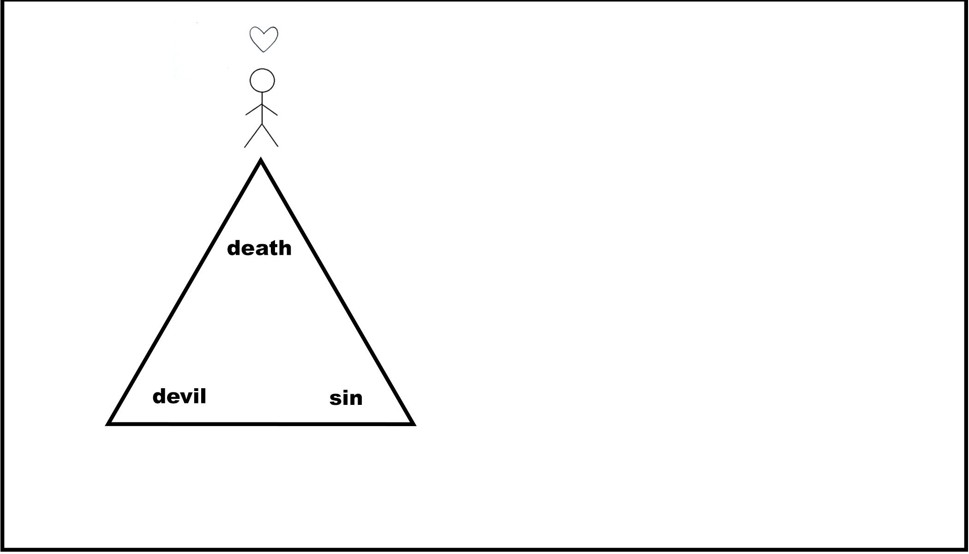
All the problems we see in the world that are caused by the devil, by sin, and by disease and death were never supposed to exist.

The Fall
But the devil tempted Adam and Eve, and they sinned, and all of a sudden everything changed (Genesis 3). Draw an arrow and another stick figure under the triangle.
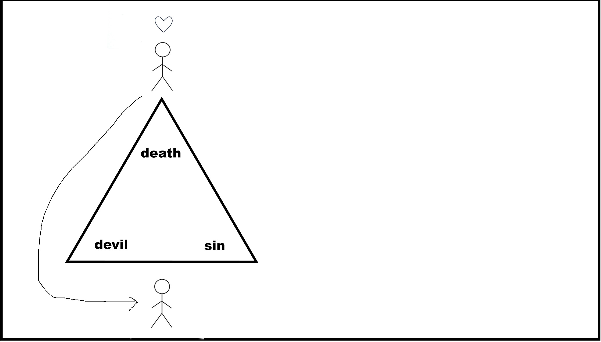
Whereas before they lived in power over the devil, now the devil had power over them. It says in the Bible that the whole world lies in the power of the devil (1 John 5:19). The devil now rules here in this earth. (Eph 2:2) We see the results of this everywhere. For example, many people experience the results of curses. Other people hear voices in the night. Still others have unexplained fear or panic attacks and encounters with demons. Apart from these more supernatural occurrences, most people give in regularly to the temptations that the devil brings. This is because the devil has ownership over that person. Every person has given into him and thus made a covenant with him so that he has the right to cause all kinds of problems in that person’s life.
It is possible to tell specific stories here of people that you know who have been bothered by the devil or curses
But it’s more than that. Adam and Eve, when they gave into the devil, also gave the right for sin to come and reign in the world (Romans 5:12)). Sin isn’t just a decision of whether to do good or bad. It’s something that owns you, like a master and a slave (Romans 6:16). Even if people want to change, everyone has a hard time doing what is right. And so we see the results of sin everywhere in our world, whether it’s alcohol or drug addiction, adultery, greed, or selfishness. What makes things worse is that the Bible talks about sins not just being external but internal. Even people who appear to be good people on the outside are often consumed by lust or anger or hatred and jealousy towards others. Many people desire a way out of these patterns of behavior and thinking, but sin has been allowed to have power over people in this world. They are hopelessly enslaved.
It’s helpful to use sins that are relevant in whatever culture where you are located. Also, notice here that I talk about sin’s current impact on our life without trying to argue that you were a sinner from birth. At some point they need to know that their sinfulness started before they ever had the power to make a decision, but it is challenging to convince people of what is really more of a theoretical concept. It’s easier to convince people that sin reigns in their lives today.
The result of the devil and sin’s entry into the world is that sickness and death also came too. In the Bible, it says that the result of our sin is death (Romans 6:23, Romans 5:12). This manifests itself in all kinds of diseases and physical death. But it also has an eternal component. Death reigns eternally over all who have fallen victim to sin and the devil, and they are made to live eternally separated from God and subject to death in a place called hell.
People do all kinds of things to try to solve this problem. To overcome the devil, they go to witch doctors or tarot card readers in order to get free of curses or to help people who are bothered by demons. But this generally doesn’t help and often makes the problem worse. People do all kinds of rituals in order to protect themselves from evil spirits, but most of the time people end up living in fear and not seeing any victory. People also do all kinds of things to change themselves and try to be better people, but even if they can come to a place where it appears that they are a good person, they can’t deal with the sins that they have on the inside.
Emphasize specific rituals or things that people do in your culture in order to try and be free from the devil
The power of the devil, sin, and death in people’s lives is like a heavy weight that people carry around and they are unable to do anything to become free. This heavy burden keeps people from having a good relationship with God and with other people.
Jesus
God loves us like a parent loves his children, except he loves us much, much more than a parent could ever love a child here on earth. Good parents, when they see their children struggling, will do everything that is in their power to help them overcome the situation. God sees this problem that we brought upon ourselves, and he didn’t leave us without a solution. He loved us enough to send Jesus (John 3:16). Draw Jesus and a heart and a triangle.
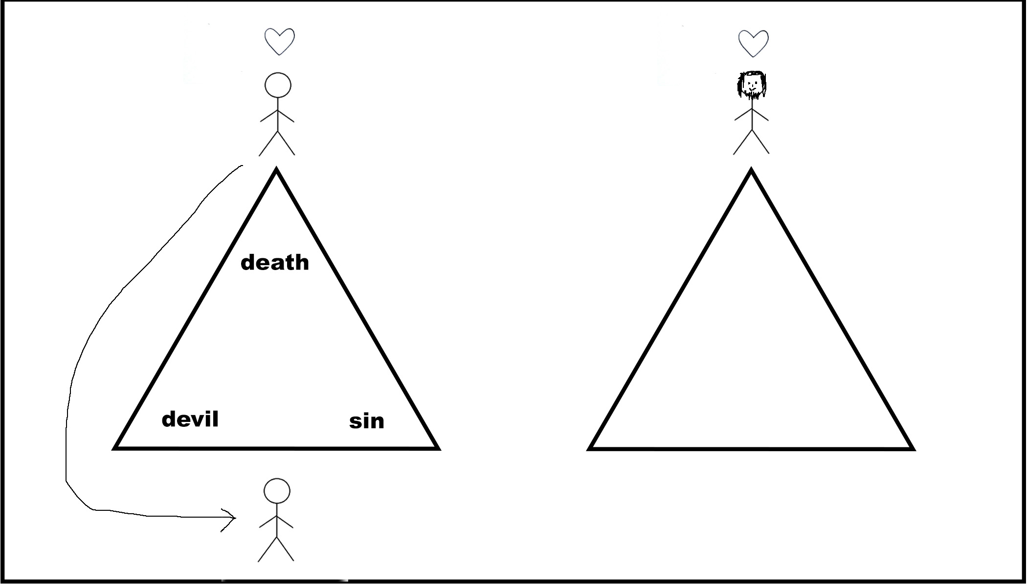
When Jesus came to earth, he had complete victory over the devil, sin, and death.
Write “Devil” in the bottom left corner of the triangle. Any time somebody came to Jesus who was possessed by a demon, Jesus would cast the demon out with a simple command. One time Jesus approached a boy who was living in a graveyard who had gone completely insane due to the presence of a demon. Nobody was able to help this boy, but Jesus cast out the demon and after that, he was found completely in his right mind (Mark 5:1-17). When the devil came to tempt Jesus, unlike any person before or after him, he resisted the devil and did not give into his temptations (Mattew 4:1-11).
Jesus also had complete authority over sin. Write the word “Sin” in the bottom right corner of the triangle. He never sinned and lived a completely holy and clean life (Hebrews 4:15).
Jesus walked in complete authority over death and disease. Write the word “Death” in the top of the triangle. He healed people with all kinds of diseases (Matthew 4:23). He even raised three people from the dead (Luke 7:11-15, 8:49-55, 24:5,6).
You can choose a healing story from Jesus’ life here in order to emphasize his power to heal.
Jesus demonstrated to us that he has authority over the devil, sin, and death.

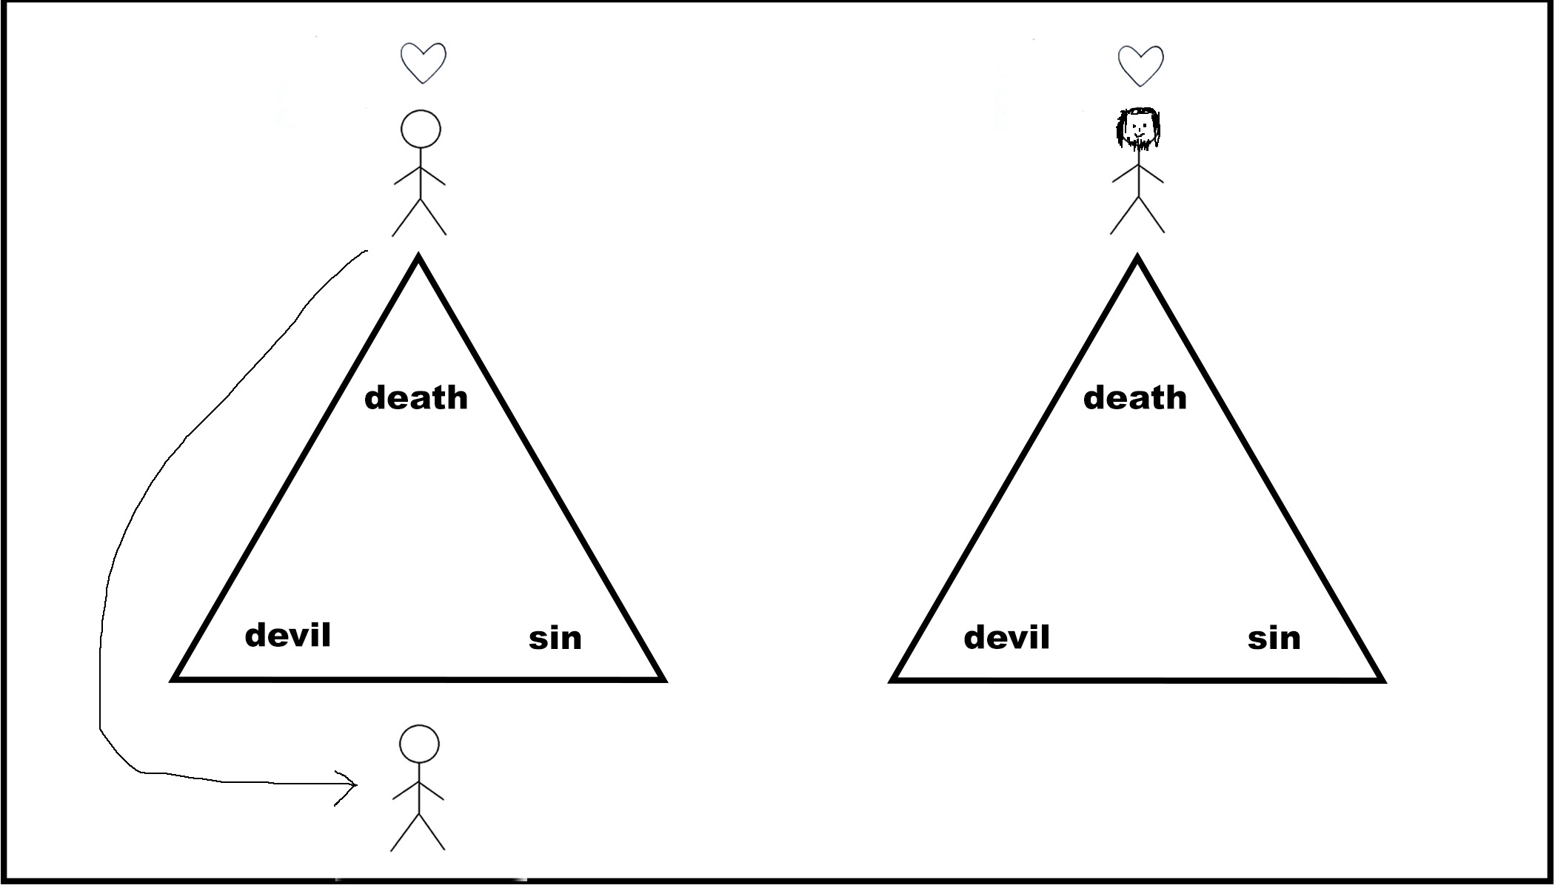

Death
When Jesus died on the cross, he took upon himself all the consequences of our sin and our covenant with the devil. Draw an arrow and a cross.
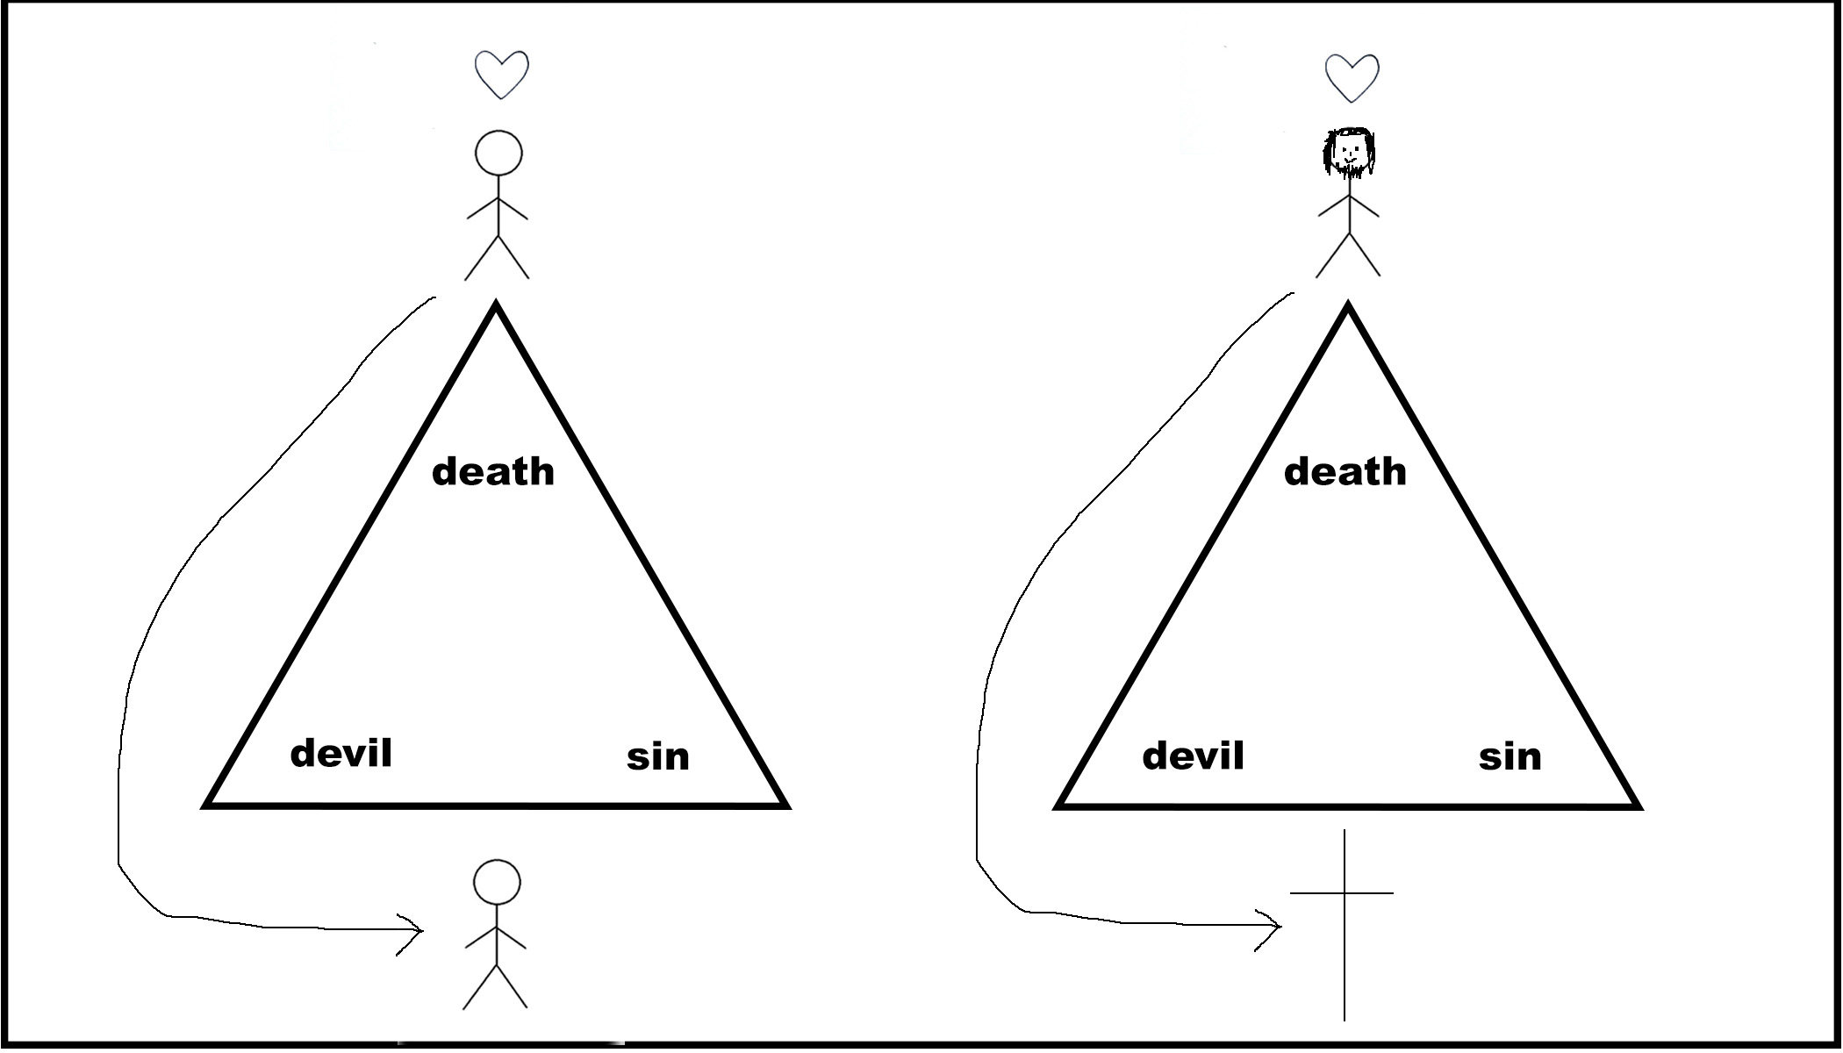
The devil had the right to curse us because of the covenant we made with him. But when Jesus died, he took that curse upon himself so that the devil’s power was destroyed (Gal 3:13, Col 2:15, Hebrews 2:14-15).
Jesus also took our sin upon himself when he died upon the cross. Every bad thing we have ever done against God or others he took upon himself.(1 Peter 2:24).
Most importantly, he took our death upon himself. He died for us, taking the penalty that we deserve for our sin. (Romans 5:8).
Resurrection
When he rose from the dead, he showed that even the power of the devil, sin, and death could not hold him down. He rose in victory and now is in heaven where he reigns over our enemies: the devil, sin and death. Draw an arrow back to the top of the triangle. Cross out death, sin, and the devil.
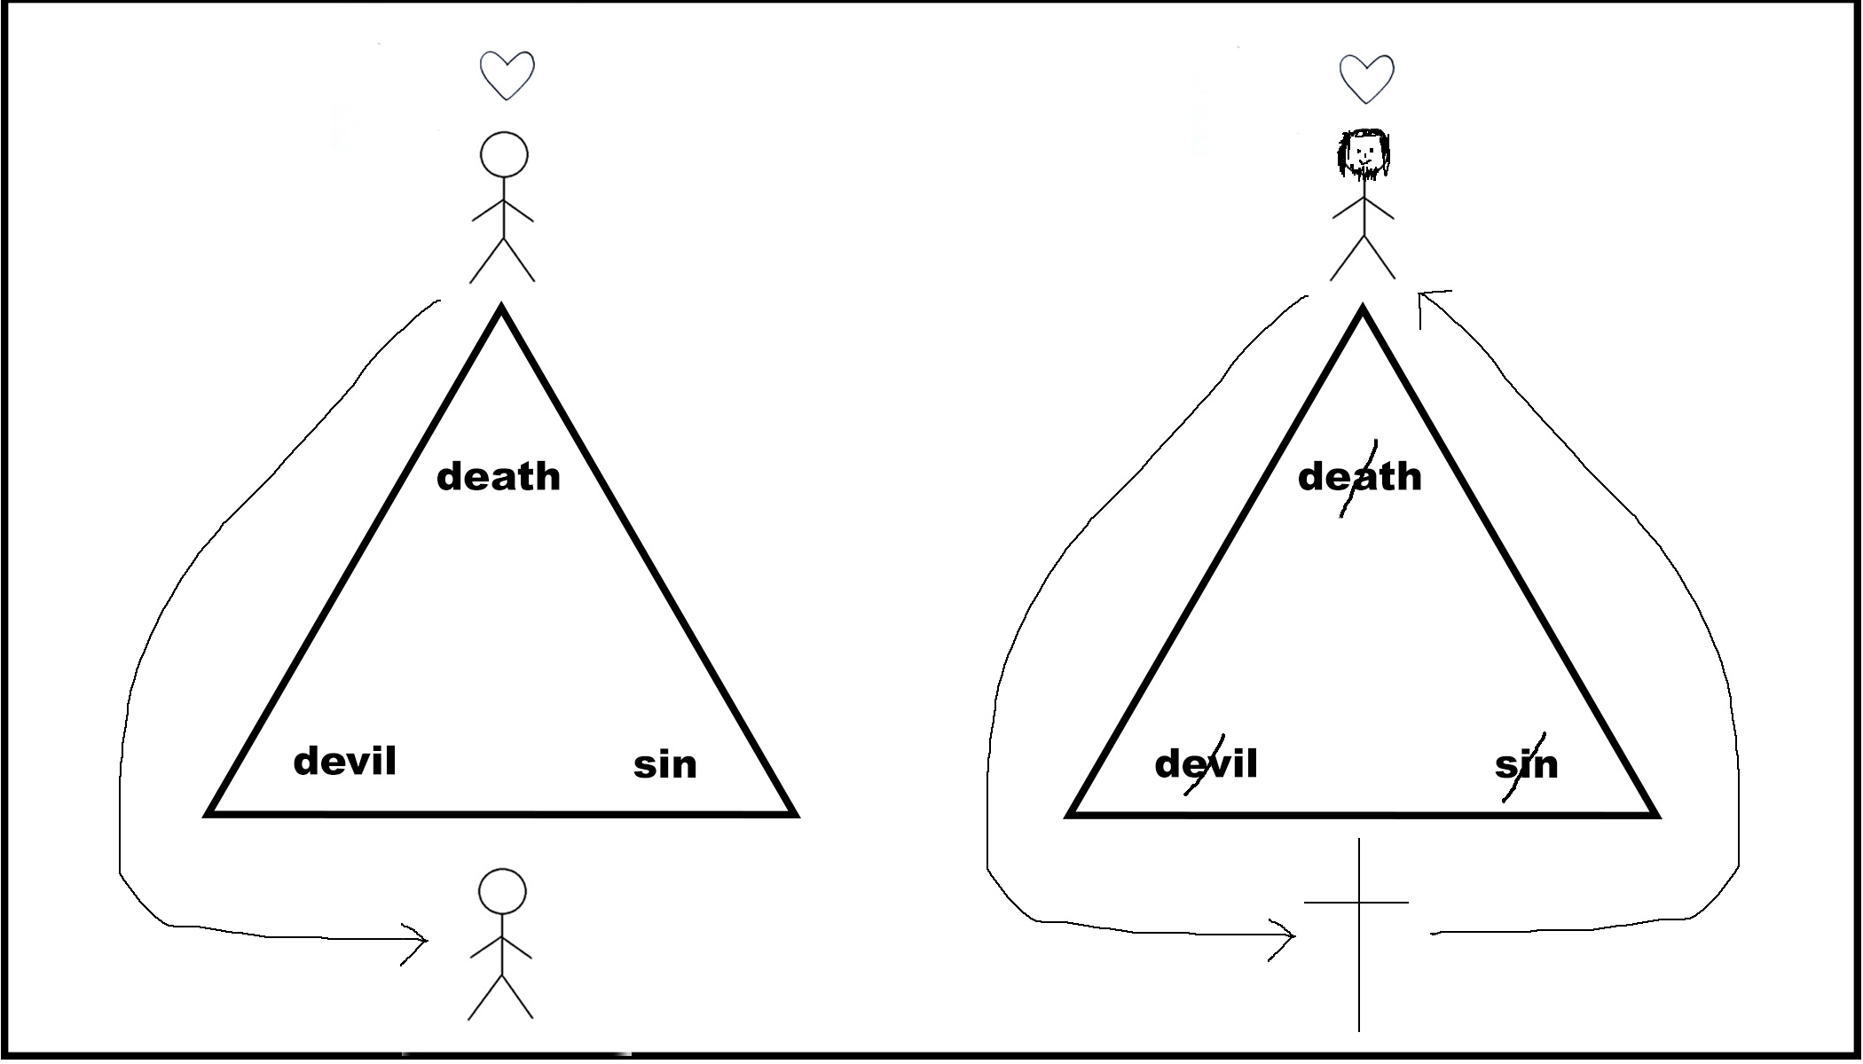
Three Steps
Jesus changed things in the world so that we could live differently and have a right relationship with God. Any person who does three things can live a different life.
1. Repent – Every person has to make a decision to turn away from the devil and from sin, to break the power of the curse and the covenant that was made with the devil. You must ask forgiveness for your sins and for all the ways that you have given yourself to sin (Mark 1:15).
2. Believe – Believe in Jesus and what he did for you on the cross. Accept the gift of his death for you and what he accomplished for you there. (Romans 10:9).
3. Commit - Trust in Jesus and obey His commands for Your life.
If you repent and believe in Jesus, you are restored to that place of authority over the devil, sin and death, and you are restored back into relationship with God.
Draw a line to Jesus and a stick figure standing next to Him with a heart on top.
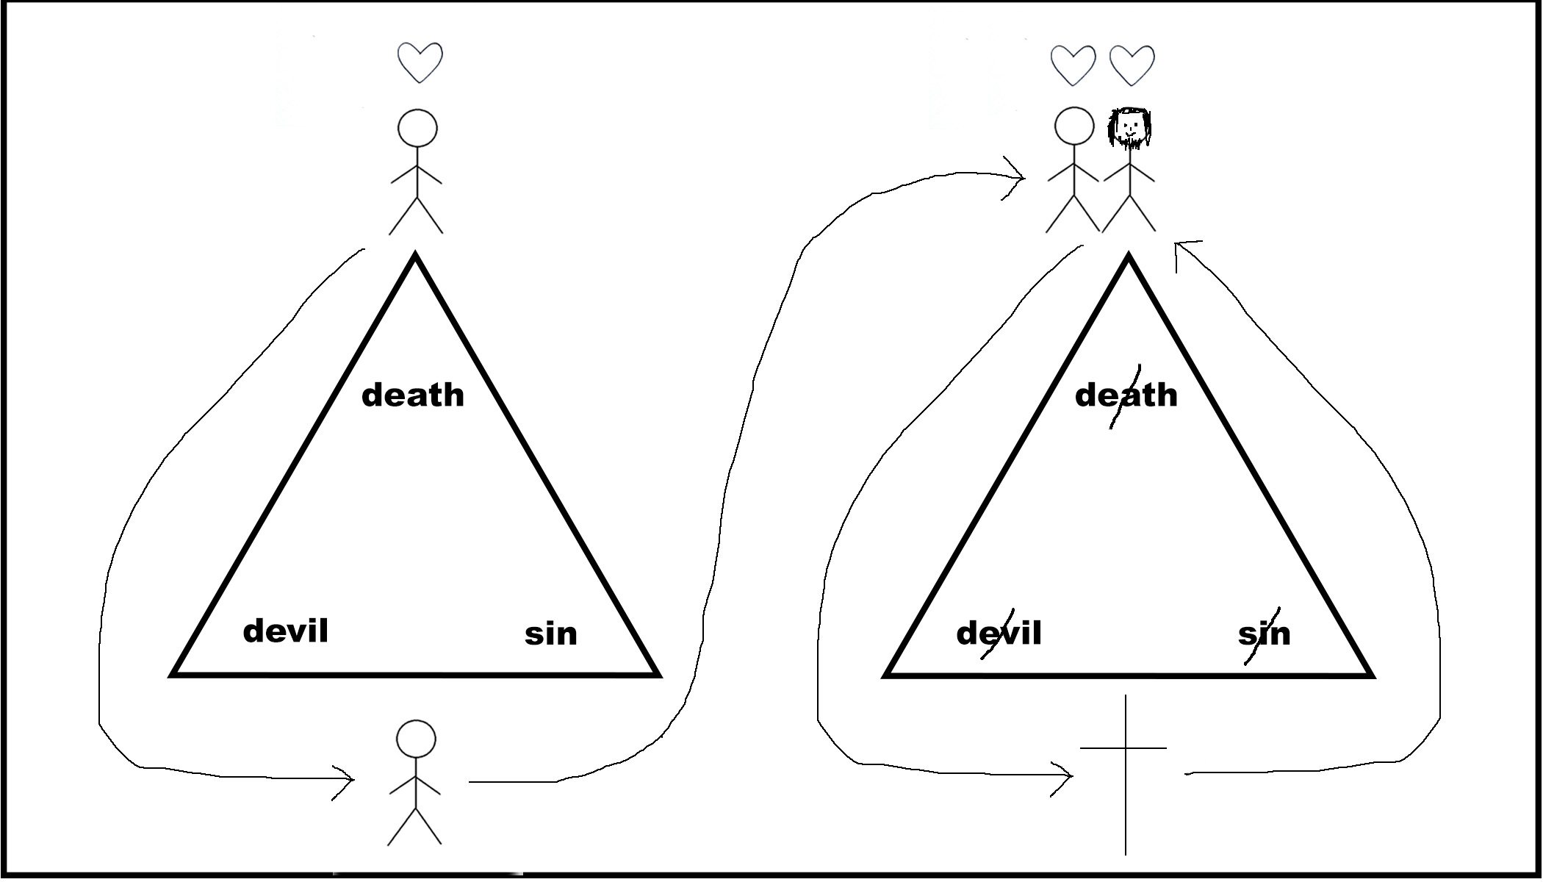
Restoration
The first thing we receive is authority over the devil. Write the word “Authority” to the left of the triangle.. Jesus promised that if we pray in His name, that we will see victory over the devil (Mark 16:17). I have experienced many battles with the devil, but time and time again, through Jesus, I have seen victory over the devil. I have prayed for many people who have suffered from problems with demons, and by praying in Jesus’ name, I have seen people set free from many kinds of problems.
It’s important here to share testimonies of times when you or someone you know has overcome the devil.
Jesus also provides us with forgiveness for our sins. Write the word “Forgiveness” under the triangle. The worst feeling is to feel shame before God, to feel that we can’t look up at Him when we pray to Him. Because Jesus died for all our sins, when we confess our sins to Him, we experience a type of cleansing that takes away the shame that we were feeling before (1 John 1:7-10). We can worship God without feeling guilty because we know we stand completely cleansed before Him.
Jesus also gives us freedom from our sins. Write the word “Freedom” under the triangle. Because he broke sin’s power, we have the ability now to make decisions that are honoring to Him (Romans 6:6-7). It doesn’t mean that we will never sin again, but it means that we are no longer victims to whatever sin wants to do in our lives. I have many times prayed to be set free from a sin and seen Jesus bring deliverance.
It’s important to have stories of times when Jesus has given you freedom from a feeling of guilt or from a specific sin.
The most important thing Jesus does is to give us eternal life (Romans 6:23). Write the words “Eternal Life” to the right of the triangle. Because he has the power over life and death, when we believe in what He did for us, we receive eternal life in heaven with God. When we die, we know we will be in heaven with God.
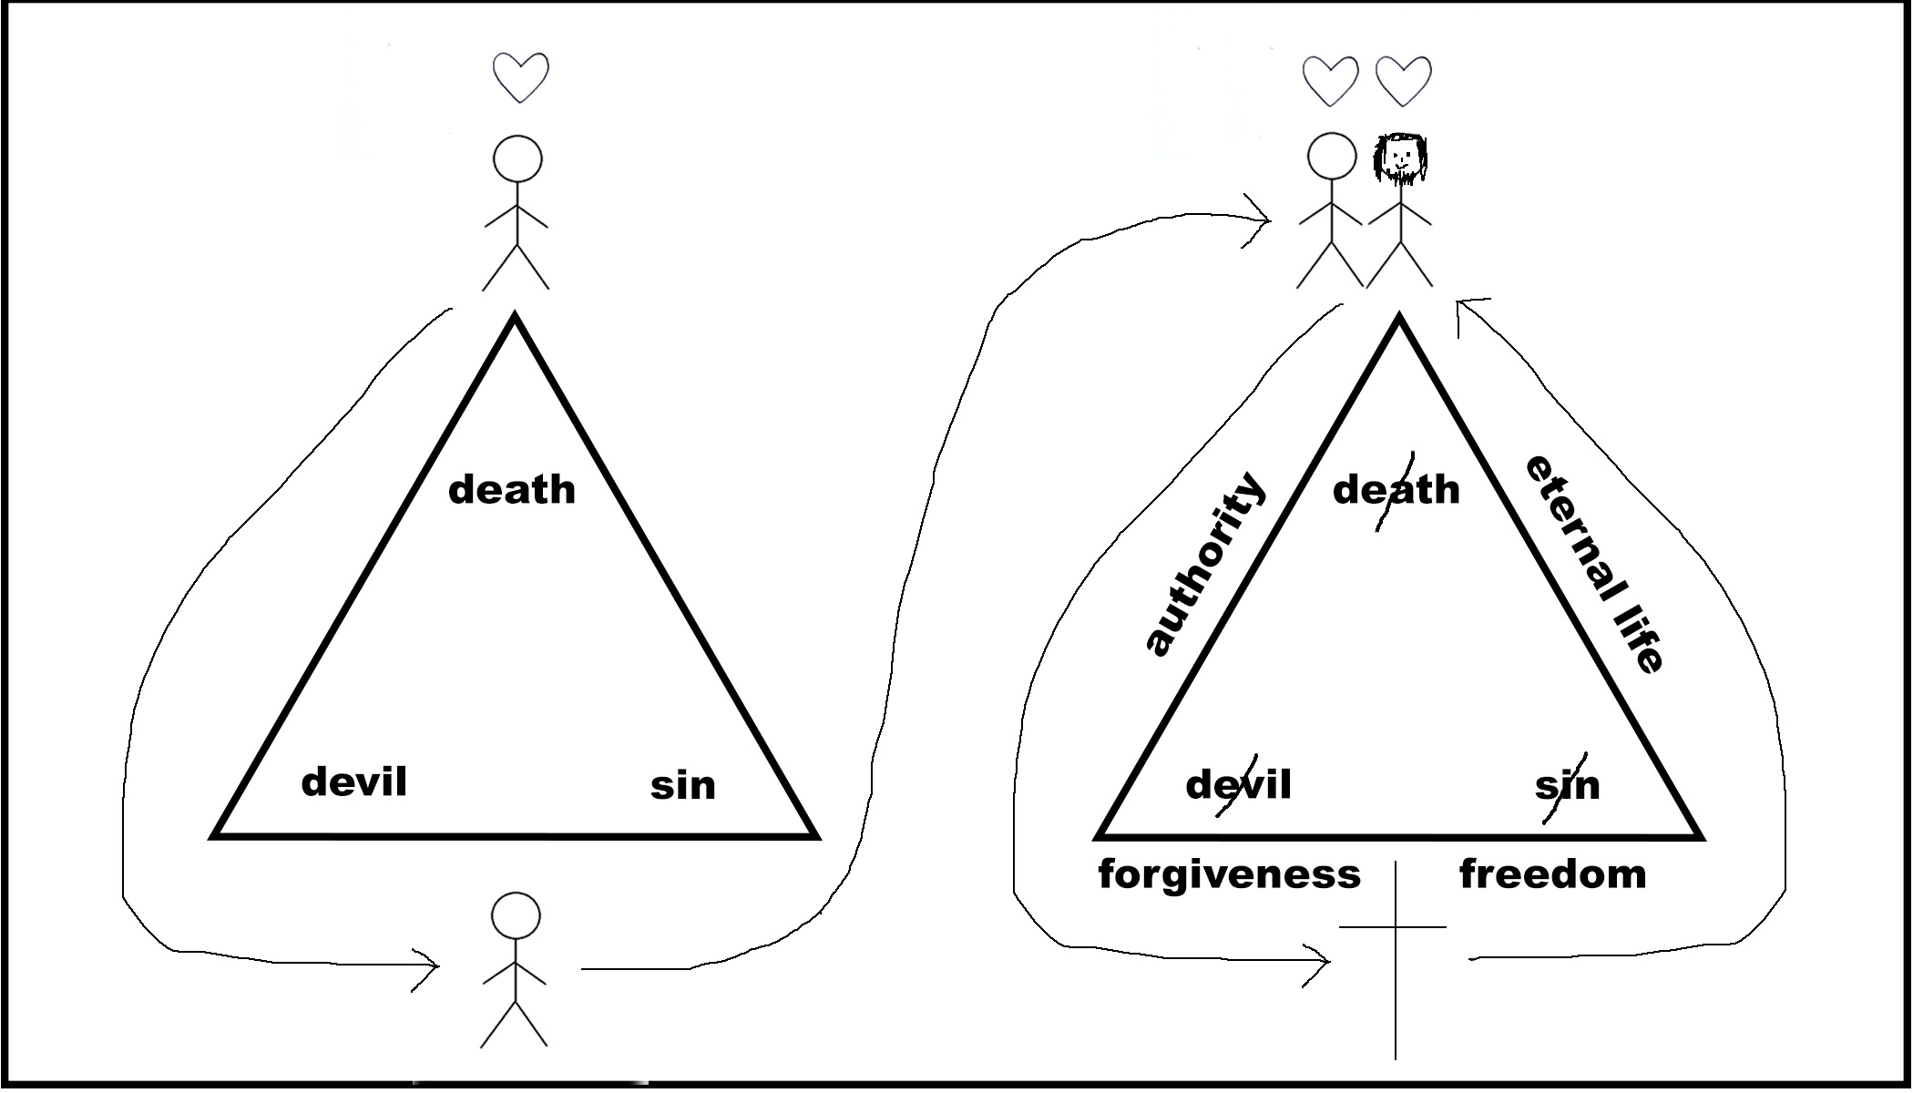
Pray with Me
There is a simple prayer that anyone can pray. If they pray this prayer with a sincere heart, God honors that and He gives them all these things: authority, forgiveness, freedom, and eternal life. God comes and breaks the root of the problem, so we can begin to live differently. It doesn’t mean a perfect life with no battles, but we begin a process of living like we were intended to live. The prayer goes like this:
“God, forgive me for my sins. I know that I have turned away from You and haven’t followed you and have allowed the devil to rule in my life. I place my faith in Jesus, I receive what he did for me on the cross, that he broke the power of the devil, sin, and death for me. I receive your love and forgiveness and blessing in my life. I receive the authority that you give me now over the devil, sin, and death. I give my life to you. In Jesus’ name. Amen.”
Everyone I pray this prayer with who prays with a genuine heart feels a sense of relief—a lightness and a peace—because they go from a place of being burdened by the weight of all these things into a place of victorious living.
Would you like to pray this prayer with me and receive forgiveness for your sins and authority over the devil and eternal life?

Appendix
Why I Came up With This
My friend and I went to coffee with a couple Muslim-background college students in order to share the gospel. We successfully steered the conversation to spiritual things and were able to share a little of our testimony and then went on to share the good news of Jesus Christ’s forgiveness for our sins and the gift of eternal life. When we got to the end, we looked at our friends hoping for some kind of response and one of the guys said with deep interest, “So are cars really cheaper in America?” This was our first indication that they didn’t care at all about what we’d said to them.
I shared the gift of forgiveness of sins and eternal life with a lot of people, but in my experience, people were uninterested in what I had to say. They didn’t understand why what I was saying was relevant to their lives, and they had their own theoretical theological systems that had other answers for the problems of our sins and the afterlife.
My friend and I shared about how nobody in our city seemed interested in the gospel with a man who was visiting us to do some consulting on church planting. He said, “Well, maybe you’re sharing the wrong gospel.” This was a man who is firmly committed to the Word of God and to Jesus, so I knew he wasn’t saying that we should make up something unbiblical just to give people what they want to hear, but in his statement I understood that we were not describing Jesus in a way that people would feel compelled to come into relationship with Him.
Jesus said the kingdom is like a merchant looking for pearls (Matt 13:45). When the man found a pearl of value, he sold everything he had and bought it. If we don’t show people the value of Jesus in a way they can understand, they will never be willing to give up all that people have to give up in order to follow Him. After reflecting on this truth, I realized that I would need to go on a journey to understand how to communicate Jesus to people so that they could know his ultimate and supreme value.
A Doorway into Greater Revelation
As I reflected on what the gospel is and how people come to know Jesus, I realized that nobody gets the fullness of the Gospel the first time.
For example, we know that it is important at some point to understand the image of Christ as the bridegroom and the church as his bride. But rarely do we share the importance of this image with people who do not yet know Jesus. It is something that is later revealed as we grow deeper in our relationship with God.
I see Gospel-sharing as a room with Jesus standing in the center. There are many doors to enter the room, and there is an old-fashioned knocker in the shape of a cross on every door. But every door has different designs and different colors and is more or less interesting to people from different cultures and backgrounds.
Thus, the cross is the center of all conversion. You cannot get to Jesus without understanding what he did for you on the cross, repenting of your sins, and believing and trusting in Him. But Jesus accomplished many things at the cross. He died to bring us into deeper relationship with God, to forgive us for our sins, to set us free from addictions, to bring us emotional and physical healing, to set us free from the devil, to deliver us from an eternity in hell, to restore our relationships with our neighbors, to restore the glory of God on earth, to identify with and show his victory over injustice, and to demonstrate love to a world that had never experienced such deep, sacrificial love.
Every presenter of the Gospel chooses a few of these benefits of the cross and emphasizes them as the Gospel is presented. Ultimately, we want people to understand all these things. But when people first hear about Jesus, they always hear only a portion of all that he did.
So I began to explore the heartfelt needs of people who are in more non-Western cultures. I started asking questions like, “What drives them? What is important to them? What are they seeking?” Because I believe Jesus is the answer to every problem, I began to use answers to those questions to shape the way I would help them understand Jesus.
Today, Not Tomorrow
There is a saying in the culture where I lived that Muslims pays for their sins after death, and a person of that local people group pays for her sins during this life. This statement sets forth a fundamental conflict that most of Islam has with animistic types of cultures: Islam offers a solution for your afterlife but has little power to affect the life you are living today.
Most people in animistic cultures are just surviving. They are trying to pull enough money together to pay for their food and necessities, and they are consumed with the basic problems of life such as the health of their children and the ability to keep their families safe from evil spirits. These are not future problems. They are today problems. And typical people aren’t thinking about eternal consequences. They’re thinking about current issues in their lives.
When a Westerner comes in and tries to communicate the Gospel, we typically emphasize the future. “Do you know what would happen to you if you died today?” Then we spend the next 30 minutes trying to convince them why this question is important and why they have a problem.
The problem of what happens to us after we die is a legitimate problem and it must be presented as a part of what Jesus has to offer us. But if it’s the only thing we present to people, we miss out on all the other kingdom benefits that Jesus wants to present to people, and we also present a gospel that doesn’t meet the real-life needs of people that we encounter.
As I began to think about this problem about the future nature of most methods of gospel-sharing, I realized that I wanted to develop a model that would emphasize the presence of the Kingdom while continuing to demonstrate how important it is that Jesus offers us a free invitation into eternity with the Father.
Christ the Victor—A Model for Sharing the Gospel
Many people have heard of Christ the Victor as a model for gospel sharing. It’s the idea that Jesus is victorious over sin, the devil, and death, and that he paved the way for us to be freed from sin, the devil, and death through his death and resurrection. I had heard that this form of the Gospel was effective with people from animistic backgrounds.
But why use a model in the first place? I decided to create a model for sharing the Gospel based on Christ the Victor for several reasons. Initially, I created it for myself. I wanted an easy way to share with people that I could use over and over again so that I wouldn’t leave out something important. I made it visual because I had seen the power of tools such as the bridge diagram and the pictures that are found in four spiritual law tracts.
I also wanted a model to help train my disciples. As a foreign worker whose longevity in the field is subject to many unforeseen variables, I want to be certain that locals are effectively able to share the Gospel. If I can’t train others to evangelize, then my work is only as effective as how much time I have. If I can train others to share the Gospel with their friends and family simply and in a way that is relevant to them, then I can move away from simple addition and move into the realms of multiplication and movements.
A Note About Power
If we’re going to proclaim that Jesus has power over sin, the devil, and death, then we must walk in that power ourselves. Theoretically, every believer has this kind of power. But the reality is that some people do not understand its importance in Gospel-sharing and so rarely ask God to do things that are outside of what they could accomplish without His help. The purpose of this manual isn’t to talk about power and authority in the Spirit, but I would encourage you to pick up this method of sharing the Gospel with a deep hunger to see God demonstrate His power through you.
God gave me this model for sharing the Gospel when I was thirsty and hungry for breakthrough, and I have shared it often in the context of praying for others. Paul said, “And my message and my preaching were not in persuasive words of wisdom, but in demonstration of the Spirit and of power, so that your faith would not rest on the wisdom of men, but on the power of God” (1 Cor 2:4-5 NASB). May the same be true of our ministry as we strive to clearly communicate the word of God accompanied by confirming signs and wonders.
One of the main reasons I came up with this method is that I wanted a way to explain to people what Jesus could do for them so that they weren’t just interested in the power that God would minister through me. Oftentimes, before I am about to pray for somebody I will say, “I would love to pray for you for healing. But before I do, would you mind if I showed you something? I want to share something with you that is much more important than anything that I could ever pray for you. I would like to show you why I think the world is so messed up and how these problems came about in the first place.”
Most people say yes, as they are at least willing to sit through what I have to say so that they can receive the prayer. Everybody wants prayer, but not everybody initially wants to hear the gospel. But many people, after hearing the gospel, want all of what Jesus has to offer and not just the healing.

